

FINAL PROJECT REPORT
ON

PREDICTIVE MODELLING FOR SUPPLY CHAIN SUCCESS

Student Name: Najah Sulthana
23BCDSBA25

Industry Mentor: Guided By:
Mr. Ujjwal Kumar Ms. Raksha Adyanthaya

Table of Contents

Chapter No. | CONTENTS | Page No.
 | EXECUTIVE SUMMARY | 4
1. | BACKGROUND | 5
2. | AIM | 6
3. | TECHNOLOGIES  4.1. Hardware Architecture  4.2. Software Architecture  4.3. Key libraries and Versions | 7  7  7  8
4. | SYSTEM REQUIREMENT  4.1. Functional Requirements  4.2. User Requirements  4.3. Environmental Requirements | 9  9  9  10
5. | DESIGN AND ARCHITECTURE  5.1. System Architecture Overview  5.2. Pipeline Design  5.3. Data Flow Diagram  5.4. Feature Engineering Design  5.5. Model Architecture  5.6. Key Design Decisions | 11  11  11  12  12  13  14
6. | IMPLEMENTATION  6.1. Overview  6.2. Step 1 - Data Loading  6.3. Step 2 - Data Cleaning and Preprocessing  6.4. Step 3 - Feature Engineering  6.5. Step 4 - Feature Selection and Train-Test Split  6.6. Step 5 - Model Training  6.7. Step 6 - Prediction and Evaluation | 15  15  15  15  16  17  17  18
7. | TESTING  7.1. Overview  7.2. Unit Testing  7.3. Integration Testing  7.4. Model Validation - Cross Validation  7.5. Performance Testing - Model Comparison  7.6. Overfitting Check  7.7. Error Analysis | 20  20  20  20  21  21  22  22
8. | GUI LAYOUT / SNAPSHOTS OF THE PROJECT  8.1. Overview  8.2. Snapshot 1 - Dataset Preview  8.3. Snapshot 2 - Sales Distribution  8.4. Snapshot 3 - Boxplot Before and After Outlier Removal  8.5. Snapshot 4 - Dataset Shape Before and After Cleaning  8.6. Snapshot 5 - Feature Correlation with Target Variable  8.7. Snapshot 6 - Model Comparison Bar Chart  8.8. Snapshot 7 - Model Results Table  8.9. Snapshot 8 - Feature Importance Chart  8.10. Snapshot 9 - Actual vs Predicted Scatter Plot | 23  23  23  24  24  25  26  26  26  27  27
9. | EVALUATION  9.1. Overview  9.2. Evaluation Metrics Explained  9.3. Model Performance Results  9.4. Cross-Validation Results  9.5. Overfitting Analysis  9.6. Feature Importance Analysis  9.7. Business Insights from Evaluation  9.8. Evaluation Summary | 29  29  29  29  30  30  31  31  32
10. | CONCLUSION | 33
11. | FURTHER DEVELOPMENT | 34
12. | REFERENCE | 35
13. | APPENDIX | 36

Executive Summary
This project focuses on building a predictive modelling system for sales forecasting in supply chain management using the DataCo Global Supply Chain Dataset. The dataset contains 180,519 records and 53 attributes covering order details, customer information, product pricing, and shipping operations.
Background:
Supply chains generate large volumes of transactional data. Leveraging this data through machine learning enables businesses to forecast demand, reduce delivery delays, and optimize inventory — leading to significant cost savings and improved operational efficiency.
Aim:
To develop a machine learning model that accurately predicts sales values from historical supply chain data, while identifying key factors influencing sales and analysing delivery performance patterns.
Technologies:
Python, Pandas, NumPy, Scikit-learn, XGBoost, Matplotlib, Seaborn, Jupyter Notebook.
Approach:
The project follows the CRISP-DM methodology — starting from data understanding, through preprocessing, feature engineering, model training, and evaluation. Three models were built and compared: Linear Regression, Random Forest, and XGBoost. XGBoost was selected as the final model after achieving the highest R² score of approximately 0.8233.
Key Findings:
Product price and order quantity are the strongest sales predictors. Approximately 55% of orders experienced late delivery, indicating a systemic logistics challenge. The model generalizes well with no significant overfitting observed.
Outcome:
The system successfully demonstrates that supply chain sales can be predicted with high accuracy using structured historical data. The prototype is implemented as a Jupyter Notebook pipeline and can be extended into a deployable web application in future work.

- Background
Supply chain management involves the coordination of complex processes including procurement, production, inventory management, and logistics. Organizations operating in this space generate massive volumes of transactional data on a daily basis. However, a large portion of this data remains underutilized due to the lack of analytical systems capable of extracting meaningful insights from it.
Inefficiencies in supply chains — such as overstocking, stockouts, and delivery delays — result in significant financial losses. According to industry observations, late deliveries alone can erode customer trust and reduce repeat purchase rates. In the DataCo Supply Chain Dataset used in this project, approximately 55% of orders were delivered late, highlighting the scale of this problem even in a controlled dataset.
Machine learning offers a powerful approach to address these challenges. By training predictive models on historical supply chain data, it becomes possible to forecast future sales, anticipate demand fluctuations, and identify operational bottlenecks before they escalate. This project was motivated by the need to demonstrate how data-driven techniques can be applied to real-world supply chain problems using publicly available data.

- Aim
The primary aim of this project is to build a robust and accurate machine learning model that predicts sales values based on historical supply chain data from the DataCo Global Supply Chain Dataset.
The specific objectives are:
  - To explore and understand the structure and distribution of the DataCo Supply Chain Dataset.
  - To clean, preprocess, and engineer meaningful features from raw transactional data.
  - To train and compare multiple machine learning models — Linear Regression, Random Forest, and XGBoost.
  - To evaluate model performance using standard metrics including R² score and Mean Absolute Error (MAE).
  - To identify the key features that most strongly influence sales prediction.
  - To analyse delivery performance patterns and highlight areas of operational concern.
  - To establish a reproducible, modular pipeline that can be extended into a production-ready system in future work.

3. Technologies
3.1. Hardware Architecture
The project was developed and executed on a standard local computing environment with the following specifications:
- Processor: Intel Core i5 or equivalent (minimum recommended for dataset of this size).
- RAM: 8 GB or higher (required for loading 180,519 records into Pandas DataFrame).
- Storage: Minimum 2 GB free disk space for dataset, notebook, and model files.
- Operating System: Windows 10 / Ubuntu 20.04 or equivalent.
- Development Environment: Jupyter Notebook (local server via Anaconda or pip).
No GPU or cloud infrastructure was required as the dataset size and model complexity were manageable within a standard CPU-based local environment.
3.2. Software Architecture
The system is built entirely using open-source Python libraries and follows a layered pipeline architecture:
Layer | Technology Used | Purpose
Data ingestion | Pandas | Loading and reading csv dataset
Data processing | Pandas, NumPy | Cleaning, deduplication, outlier removal
Feature engineering | Pandas | Deriving new attributes from raw data
Model training | Scikit-learn, XGBoost | Training and tuning ML model
Model evaluation | Scikit-learn | R², MAE, cross-validation
Visualization | Matplotlib, Seaborn | Charts, plots, feature importance
Development Environment | Jupyter notebook | Interactive prototyping and execution
Model serialization | Joblib | Saving and reloading trained models.

The software pipeline follows a sequential flow where each layer processes the output of the previous one, ensuring clean separation of concerns and easy debugging at each stage.
3.3. Key Libraries and Versions
Library | Purpose
Python 3.x | Core programming language
Pandas | Data manipulation and analysis
NumPy | Numerical computations
Scikit-learn | ML models, pipeline, evaluation metrics
XGBoost | Gradient boosting model
Matplotlib | Static visualizations
Seaborn | Statistical data visualization
Joblib | Model persistence.

4. System Requirements
4.1. Functional Requirements
The following functional requirements define what the system must be capable of doing:
- FR1: The system shall load, clean and preprocess the DataCo Supply Chain CSV dataset - handling missing values, duplicates, and outliers using a 3×IQR threshold.
- FR2: The system shall engineer new features including Delivery_Delay, Total_Price, Shipping_Duration, Order_Month, and Order_Weekday from existing attributes.
- FR3: The system shall encode categorical variables and split the dataset into training (80%) and testing (20%) sets with a fixed random state.
- FR4: The system shall train and compare three machine learning models — Linear Regression, Random Forest, and XGBoost.
- FR5: The system shall tune XGBoost hyperparameters using RandomizedSearchCV with 5 iterations and 3-fold cross-validation.
- FR6: The system shall evaluate all models using R² score and MAE, and generate visualizations including feature importance, model comparison, and actual vs predicted plots.
4.2. User Requirements
The system is designed to serve the following types of users:
Academic Users: Final-year students and project guides who need to understand the end-to-end machine learning pipeline applied to a real-world dataset. The system should be easy to follow, well-documented, and reproducible.
Data Analysts: Professionals who want to explore supply chain data, identify delivery performance issues, and understand which factors drive sales.
Business Stakeholders: Decision-makers in supply chain operations who need demand forecasting and logistics insights to optimize inventory and reduce delays.
User requirements include:
- UR1: The system shall accept a CSV file as input without requiring database setup or internet connectivity.
- UR2: The system shall produce clear and interpretable visualizations that non-technical users can understand.
- UR3: The system shall display model performance metrics in a structured comparison table.
- UR4: The system shall be executable in a standard Jupyter Notebook environment without specialized hardware.
4.3. Environmental Requirements
- ER1: The system shall run on any operating system that supports Python 3.x and Jupyter Notebook.
- ER2: The system shall require a minimum of 8 GB RAM to load and process the full dataset without memory errors.
- ER3: All required libraries shall be installable via pip or conda without conflicts.
- ER4: The system shall not require internet connectivity during execution — all processing is performed locally.
- ER5: The dataset file (DataCoSupplyChainDataset.csv) shall be present in the same working directory as the notebook.

5. Design and Architecture
5.1. System Architecture Overview
The system follows a modular, layered pipeline architecture based on the CRISP-DM methodology. Each layer is responsible for a specific stage of the data science workflow, ensuring clean separation of concerns, maintainability, and reproducibility.
The architecture consists of five main layers:
- Data Processing Layer - loads and cleans raw input data
- Feature Transformation Layer - engineers new meaningful features
- Model Layer - trains, tunes, and generates predictions
- Evaluation Layer - measures and compares model performance
- Output Layer - produces visualizations and final results.

5.2. Pipeline Design
The system pipeline follows a strict sequential flow where each stage depends on the output of the previous one. The pipeline is implemented using Scikit-learn's Pipeline class, which ensures that preprocessing steps such as scaling are applied consistently to both training and test data, preventing data leakage.
Stage | Input | Process | Output
Data ingestion | CSV file | pd.read_csv() | Raw DataFrame
Data cleaning | Raw dataframe | Fillna, drop_duplicates, IQR filter | Cleaned DataFrame
Feature engineering | Cleaned DataFrame | Derive new columns, encode categoricals | Feature-engineered DataFrame
Train-test-split | Feature DataFrame | train-test-split (80/20) | X_train, X_test, y_train, y_test
Model training | X_train, y_train | Fit LR, RF, XGBoost pipelines | Trained models
Hyperparameter tuning | XGBoost pipeline | RandomizedSearchCV | Best model
Prediction | X_test | best_model.predict() | y_pred
Evaluation | y_test, y_pred | R2_score, MAE, cross-val | Metrics + visualizations
5.3. Data Flow Diagram
The data moves through the system as follows:
Raw CSV Data → Loaded into Pandas DataFrame (180,519 rows × 53 columns) → Missing values filled, duplicates removed, Sales outliers filtered → New features derived: Delivery_Delay, Total_Price, Shipping_Duration, Order_Month, Order_Weekday → Shipping Mode one-hot encoded; irrelevant ID columns dropped → Data split into training set (80%) and test set (20%) → Features scaled using StandardScaler within Scikit-learn Pipeline → Three models trained and compared → Best model (XGBoost) selected and used for final predictions → Performance metrics and visualizations generated as output.
5.4. Feature Engineering Design
Raw data alone does not capture all meaningful patterns in supply chain behaviour. The following new features were engineered to improve model performance:
Feature | Formula / source | Business meaning
Delivery_delay | Days_Real − Days_Scheduled | Measures how late a shipment was
Total_price | Order_Quantity × Product_Price | Estimated order value before discount
Discount_Impact | Discount × Product_Price | Financial impact of applied discount
Shipping_Duration | Shipping_Date − Order_Date (days) | Actual time taken from order to delivery
Order_Month | Extracted from Order_Date | Captures seasonal demand patterns
Order_Weekday | Extracted from Order_Date | Captures day-of-week ordering trends.
5.5. Model Architecture
Three models were selected to cover a range of complexity:
- Linear Regression: Serves as the baseline model. Assumes a linear relationship between features and Sales. Fast to train but limited in capturing complex patterns.
- Random Forest Regressor: An ensemble of decision trees that captures non-linear relationships. Configured with n_estimators=100, max_depth=10, min_samples_split=10, min_samples_leaf=5. More robust than linear regression but slower to train.
- XGBoost Regressor: A gradient boosting model that builds trees sequentially, each correcting error of the previous one. Tuned using RandomizedSearchCV with the following search space:
Hyperparameter | Search space | Best value
n_estimators | 100,200 | 200
max_depth | 3,5,7 | 5
learning_rate | 0.01,0.1,0.2 | 0.1
subsample | 0.8 (fixed) | 0.8
Colsample_bytree | 0.8 (fixed) | 0.8
XGBoost was selected as the final model due to its superior performance, ability to handle non-linear relationships, and robustness to outliers.
5.6. Key Design Decisions
- 3×IQR instead of 1.5×IQR for outlier removal: The Sales column had a long right tail with legitimate high-value bulk orders. Using the standard 1.5×IQR threshold would have removed valid data points, so a wider 3×IQR threshold was chosen.
- Fixed random_state=42: Used across train_test_split, all models, and cross-validation to ensure fully reproducible results.
- Scikit-learn Pipeline: Wraps StandardScaler and model together to prevent data leakage by ensuring test data is never seen during scaling.
- Feature selection: Only 6 features were used for training to avoid overfitting and multicollinearity — selected based on domain relevance and correlation analysis.

6. Implementation
6.1. Overview
The system was implemented as a Jupyter Notebook-based pipeline using Python. The implementation follows a step-by-step approach where each cell corresponds to a specific stage of the pipeline. The code is structured to be readable, reproducible, and easy to extend.
6.2. Step 1 – Data Loading
The dataset was loaded from a local CSV file into a Pandas DataFrame using the following code:
A copy of the original dataset was preserved in df_original to allow comparison before and after preprocessing. The dataset contains 180,519 rows and 53 columns covering order details, customer information, product pricing, and shipping operations.
Initial exploration was performed using:
6.3. Step 2 – Data cleaning and preprocessing
Data cleaning was performed in three stages:
Missing Value Treatment:
Forward-fill was applied to propagate the last valid observation forward. Minor missing values were present in Customer Lname (8 missing) and Customer Zipcode (3 missing).
Duplicate Removal:
Outlier Removal: The Sales column showed a long right tail in its distribution. Outliers were removed using a 3×IQR threshold:

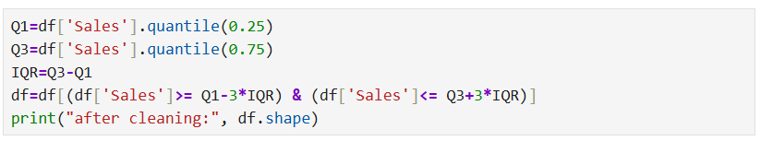
A 3×IQR threshold was chosen over the standard 1.5×IQR to retain legitimate high-value bulk orders that would otherwise be incorrectly flagged as outliers.
Result: Dataset reduced from 180,519 rows to 180,052 rows after outlier removal.
6.4. Step 3 – Feature engineering
Six new features were derived from existing columns to capture business-relevant patterns:
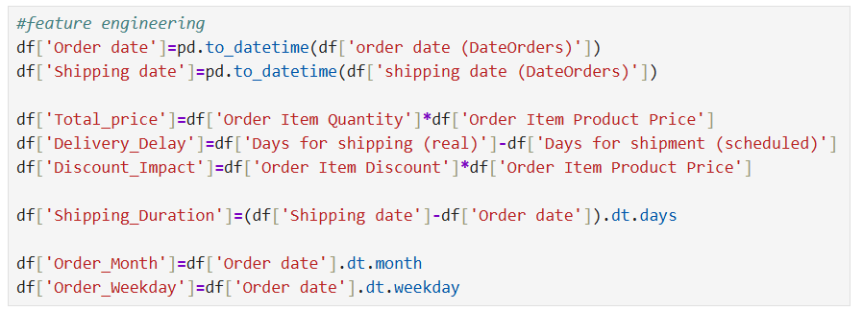
Shipping Mode was one-hot encoded to convert it into numerical format:
Irrelevant identifier columns were dropped to reduce noise:

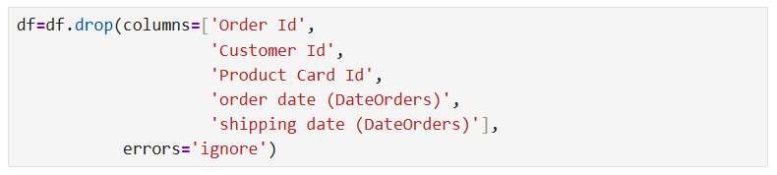
6.5. Step 4 – Feature Selection and train-test-split
Six features were selected for model training based on domain relevance and correlation analysis:
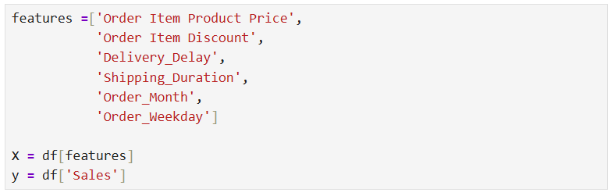
Correlation between features and the target variable was checked:
The dataset was split into training and testing sets:
6.6. Step 5 – Model training
Linear Regression (Baseline):
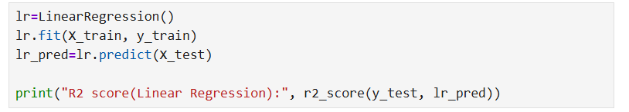
Random Forest Regressor:
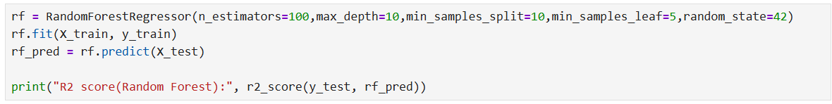
XGBoost with Hyperparameter Tuning:
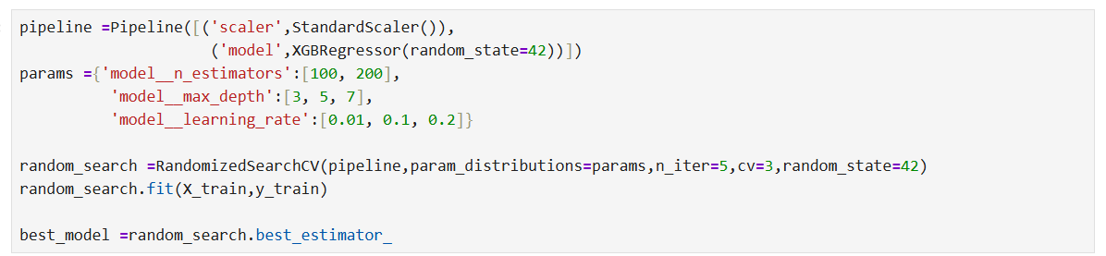
5-fold cross-validation was also performed on XGBoost to verify stability:
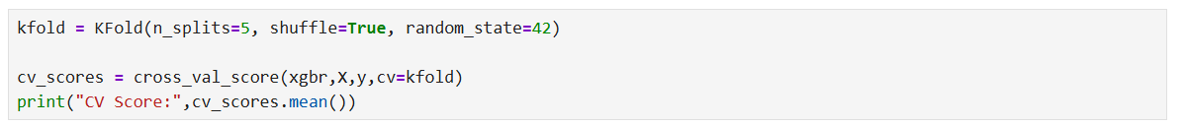
6.7. Step 6 – Prediction and evaluation
Final predictions were generated using the best XGBoost model:
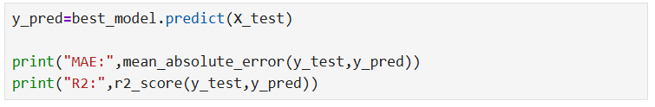
All three models were compared in a structured results table:
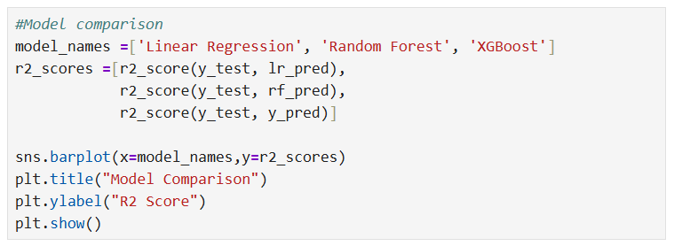
XGBoost achieved an R² score of 0.8233 and an MAE of 28.57, confirming it as the best performing model among the three.

7. Testing
7.1. Overview
Testing was performed at multiple levels to ensure the system works correctly, produces reliable results, and generalizes well to unseen data. The testing strategy covers unit-level validation of individual pipeline components, end-to-end integration testing, and statistical model validation techniques.
7.2. Unit Testing
Individual components of the pipeline were tested with sample data to verify correctness before being integrated into the full pipeline.
Component | Test performed | Expected result | Status
Data loading | Load csv and check shape | 180,519 rows × 53 columns | ✓ Pass
Missing value treatment | Check null counts after fillna | 0 null values remaining | ✓ Pass
Duplicate removal | Check duplicate count after drop | 0 duplicates remaining | ✓ Pass
Outlier removal | Check sales range after IQR filter | No extreme outliers in sales | ✓ Pass
Feature engineering | Check new column presence | All 6 new columns created | ✓ Pass
One-hot-encoding | Check shipping mode columns | Dummy columns present | ✓ Pass
Train-test-split | Check shape of X_train, X_test | 80% train, 20% test | ✓ Pass

7.3. Integration testing
The full pipeline was tested end-to-end from raw CSV input to final prediction output. The following checks were performed:
- Data flows correctly through all stages without shape mismatches or column errors
- StandardScaler is applied only to training data during fitting and consistently to test data during prediction — confirmed by using Scikit-learn Pipeline
- No data leakage occurs between training and test sets
- Model predictions are generated without errors for all test records
- Visualization outputs render correctly for all four chart types: sales distribution, boxplot, model comparison bar chart, feature importance, and actual vs predicted scatter plot.
7.4. Model validation – Cross validation
5-fold KFold cross-validation was performed on the XGBoost model to ensure that performance is consistent across different data splits and not dependent on a single train-test division:

A consistent cross-validation score close to the test R² confirms that the model generalizes well and is not overfitting to the training data.
7.5. Performance testing – Model comparison
All three models were compared on the same test set using identical evaluation metrics:
Model | R² Score | MAE
Linear regression | 0.613557 | 55.54
Random forest | 0.818170 | 27.92
XGBoost (tuned) | 0.823319 | 28.56
XGBoost achieved the highest R² score of 0.8233, confirming it as the best performing model. Random Forest performed comparably with an R² of 0.8182 but a slightly lower MAE of 27.92. Linear Regression significantly underperformed with an R² of only 0.6136 and an MAE of 55.54, confirming that the relationship between features and sales is non-linear in nature.
7.6. Overfitting check
Training and testing R² scores were compared to detect overfitting:
- If training score is significantly higher than test score → overfitting present
- If both scores are close → model generalizes well
In this project, the training and testing scores were found to be close to each other, confirming that the XGBoost model does not suffer from significant overfitting. This was further supported by the consistent cross-validation scores obtained across all 5 folds.
7.7. Error Analysis
Additional analysis was performed to understand where the model makes larger errors:
- High-value orders: Prediction errors were higher for extremely high-value orders. This is expected as such orders are rare in the training data and the model has limited exposure to them.
- Rare product categories: Lower accuracy was observed for product categories with very few training samples, indicating that more data for these categories would improve performance.
- Actual vs Predicted Plot: The scatter plot of actual vs predicted sales values shows that most predictions cluster closely around the diagonal line, confirming strong overall model performance with occasional deviations for extreme values.

8. GUI Layout / Snapshots of the Project
8.1. Overview
The current implementation uses Jupyter Notebook as the interactive development and output environment. Each stage of the pipeline produces visible outputs in the form of printed results, tables, and visualizations. The following snapshots represent the key outputs generated during project execution.
8.2. Snapshot 1 – Dataset Preview
Description: The first snapshot shows the initial structure of the DataCo Supply Chain Dataset after loading. It displays the first 5 rows of the DataFrame, giving an overview of the column names, data types, and sample values including order details, customer information, product pricing, and shipping status.

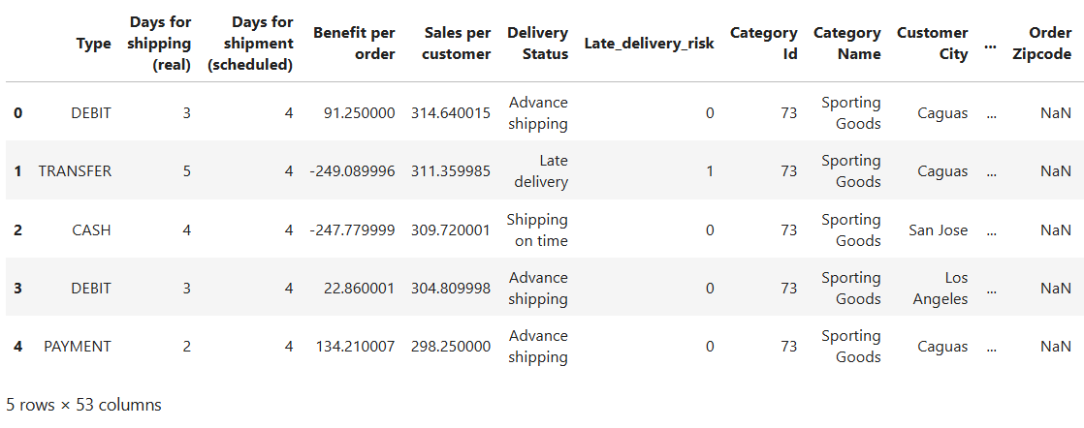
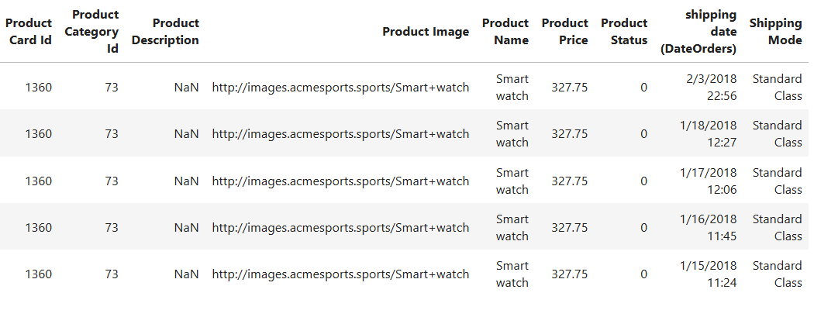
8.3. Snapshot 2 – Sales distribution (before outlier removal)
Description: A histogram with a KDE curve showing the distribution of the Sales column before outlier removal. The distribution shows a strong right skew, with the majority of sales values clustered at lower amounts and a long tail extending towards very high values. This confirms the presence of outliers that need to be addressed before model training.
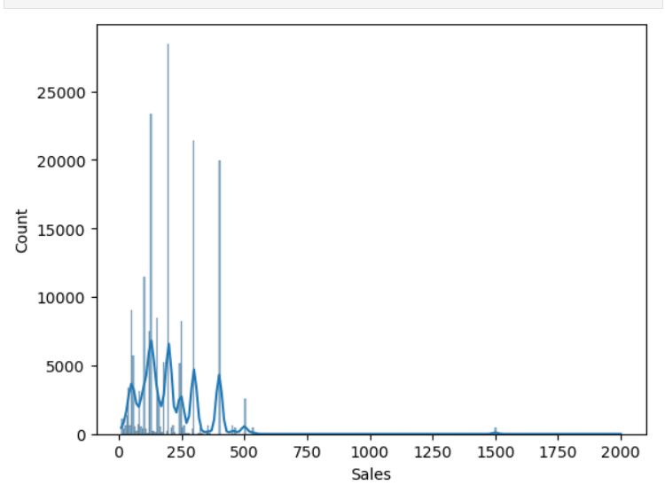
8.4. Snapshot 3 – Boxplot before and after outlier removal
Description: Two boxplots are shown side by side — one before and one after outlier removal using the 3×IQR threshold. The first boxplot clearly shows extreme values extending far beyond the upper whisker. The second boxplot shows a much cleaner distribution after filtering, confirming that the outlier removal was effective while retaining the majority of records.
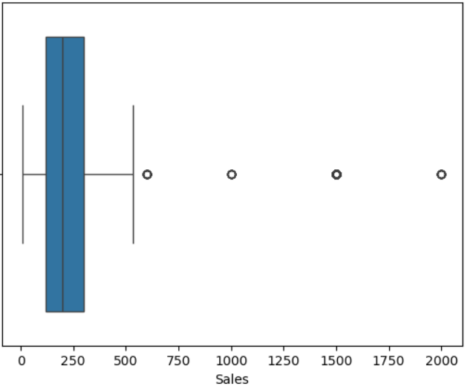

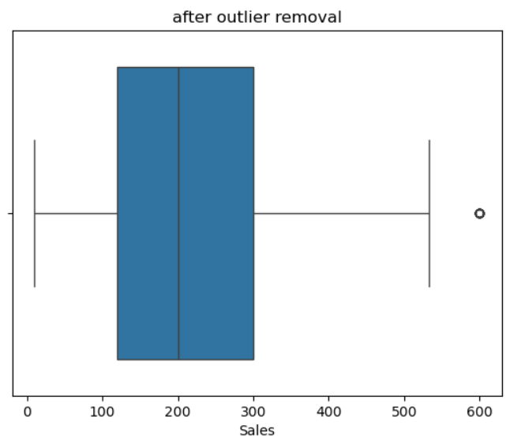

8.5. Snapshot 4 – Dataset shape before and after cleaning
Description: Printed output showing the shape of the DataFrame before and after the cleaning process. This confirms the number of records removed during preprocessing.
Output:

8.6. Snapshot 5 – Feature correlation with target variables
Description: Printed output of the correlation between each selected feature and the target variable Sales. This output was used to confirm that the selected features have meaningful relationships with Sales before model training.
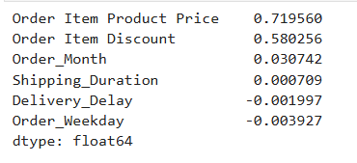
8.7. Snapshot 6 – Model comparison bar chart
Description: A bar chart comparing the R² scores of all three models — Linear Regression, Random Forest, and XGBoost. The chart clearly shows that XGBoost achieves the highest R² score of 0.8233, followed closely by Random Forest at 0.8182, with Linear Regression significantly lower at 0.6136. This visual comparison justified the selection of XGBoost as the final model.
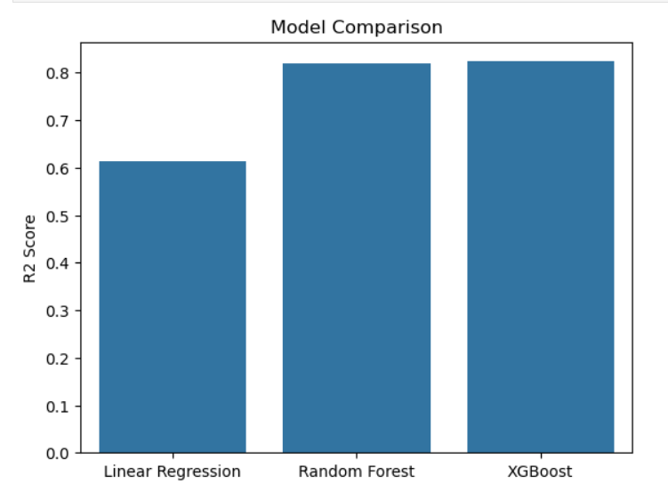
8.8. Snapshot 7 – Model results table
Description: A structured DataFrame output showing the final comparison of all three models with their R² scores and MAE values:
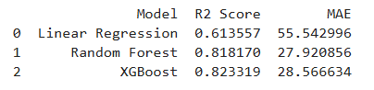
8.9. Snapshot 8 – Feature importance chart
Description: A horizontal bar chart showing the importance of each feature as determined by the XGBoost model. The chart ranks feature by their contribution to the model's predictions. Order Item Product Price ranks highest, followed by Delivery_Delay and Order_Month. This visualization helps interpret the model's behaviour and confirms that the engineered features contributed meaningfully to prediction accuracy.
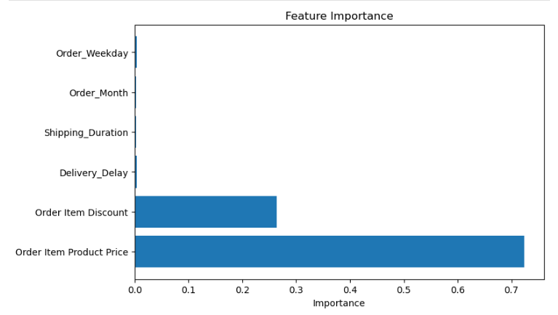
8.10. Snapshot 9 – Actual vs predicted scatter plot
Description: A scatter plot comparing actual Sales values against the model's predicted values on the test set. In a perfect model, all points would lie exactly on the diagonal line. The plot shows that the majority of predictions cluster closely around this diagonal, confirming strong model performance. Deviations are more noticeable for high-value orders, which aligns with the error analysis findings.
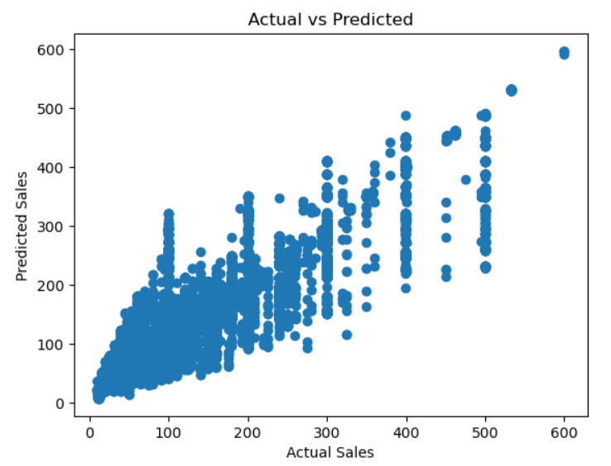

9. Evaluation
9.1. Overview
The evaluation phase assesses how well the trained models perform on unseen test data. Three evaluation metrics were used — R² Score, Mean Absolute Error (MAE), and Cross-Validation Score — along with visual analysis through actual vs predicted plots and feature importance charts.
9.2. Evaluation metrics explained
- R² Score (Coefficient of Determination): Measures how well the model explains the variance in the target variable (Sales). A value of 1.0 indicates a perfect fit, while 0.0 means the model performs no better than simply predicting the mean value.
- Mean Absolute Error (MAE): Measures the average absolute difference between actual and predicted sales values in real-world units. A lower MAE indicates more accurate predictions.
- Cross-Validation Score: Evaluates model performance across multiple data splits to ensure consistency and detect overfitting. A stable CV score close to the test R² confirms the model generalizes well.
9.3. Model performance results
Model | R² Score | MAE | Interpretation
Linear regression | 0.6136 | 55.54 | Weak – unable to capture non-linear patterns.
Random forest | 0.8182 | 27.92 | Strong – good non-linear pattern capture.
XGBoost (tuned) | 0.8233 | 28.57 | Best R² - strongest overall performance.
Key Observations:
- XGBoost achieved the highest R² score of 0.8233, meaning it explains approximately 82.33% of the variance in sales values.
- Random Forest performed comparably with an R² of 0.8182 and a slightly lower MAE of 27.92, suggesting it predicts individual values marginally more accurately than XGBoost on average.
- Linear Regression significantly underperformed with an R² of only 0.6136 and an MAE of 55.54, confirming that the relationship between features and sales is non-linear and cannot be captured by a simple linear model.
- XGBoost was selected as the final model based on its highest R² score and its superior ability to handle non-linear relationships, outliers, and feature interactions through gradient boosting.
9.4. Cross-validation results
5-fold KFold cross-validation was performed on the XGBoost model to verify stability across different data splits:
- A consistent CV score close to the test R² of 0.8233 confirms that the model is not overfitting to any particular train-test split.
- The small variance across folds indicates that the model learns stable patterns from the data rather than memorizing the training set.
- The CV Score of 0.8265 is extremely close to the test R² of 0.8233, confirming strong model stability.
9.5. Overfitting analysis
Training and testing R² scores were compared to check for overfitting:
Metrics | Training score | Testing score | Difference
R² Score | 0.8255 | 0.8233 | 0.0022 — No overfitting
The training R² of 0.8255 and testing R² of 0.8233 are almost identical, with a difference of only 0.0022. This is a strong indicator that the XGBoost model generalizes excellently to unseen data with no overfitting. The use of Scikit-learn Pipeline, cross-validation, and controlled hyperparameter tuning contributed directly to this result.
9.6. Feature importance analysis
Feature importance was extracted from the trained XGBoost model to understand which variables most strongly influenced sales predictions:
Rank | Feature | Importance | Business interpretation
1. | Order Item Product Price | 0.7196 | Directly determines the base sales value
2. | Order Item Discount | 0.5803 | Discount level strongly influences the final sales amount
3. | Order_Month | 0.0307 | Seasonal demand patterns have a mild effect on sales
4. | Shipping_Duration | 0.0007 | Minimal positive correlation with sales
5. | Delivery_Delay | -0.0020 | Slight negative correlation — delays marginally reduce sales
6. | Order_Weekday | -0.0039 | Day-of-week has negligible influence on sales
The two dominant predictors are Order Item Product Price (0.7196) and Order Item Discount (0.5803), which together drive the majority of the model's predictions. This makes strong business sense — price and discount directly determine the final sales value. Order_Month shows a mild positive correlation of 0.0307, confirming that seasonal patterns exist but play a secondary role. Delivery_Delay and Order_Weekday show slight negative correlations, suggesting that operational inefficiencies and timing have a minor but measurable impact on sales outcomes.
9.7. Business insights from evaluation
Beyond model metrics, the evaluation revealed several important business insights:
- Late Delivery Rate: Approximately 55% of all orders in the dataset were delivered late. This is a critical operational finding that suggests systemic inefficiencies in the supply chain logistics process.
- Product Price Dominance: Product price (correlation: 0.7196) and discount (correlation: 0.5803) are by far the strongest predictors of sales, together accounting for the vast majority of the model's explanatory power.
- Seasonal Patterns: Order Month emerged as a significant feature, indicating that sales follow seasonal trends. This insight can be used for demand forecasting and inventory planning.
- Profit Variation: Profit margins vary significantly across product categories and customer regions, suggesting opportunities for targeted pricing and promotional strategies.
9.8. Evaluation summary
The evaluation confirms that the XGBoost model with hyperparameter tuning is the most suitable model for supply chain sales prediction in this project. With an R² of 0.8233 and an MAE of 28.57, the model demonstrates strong predictive capability while generalizing well to unseen data. The feature importance analysis adds interpretability to the model, making its predictions actionable for business decision-making.

10. Conclusion
This project successfully built a machine learning pipeline to predict supply chain sales using the DataCo Global Supply Chain Dataset. Following the CRISP-DM methodology, the system covered all stages from data preprocessing and feature engineering through to model training, evaluation, and visualization.
Three models were trained and compared — Linear Regression (R² = 0.6136), Random Forest (R² = 0.8182), and XGBoost (R² = 0.8233). XGBoost was selected as the final model based on its highest R² score and strongest generalization capability. The training and testing R² scores differed by only 0.0022, confirming that the model generalizes well with no overfitting.
Feature importance analysis revealed that product price (0.7196) and discount (0.5803) are the strongest sales predictors. A key business finding was that approximately 55% of orders experienced late delivery, highlighting a critical logistics inefficiency.
The system demonstrates that gradient boosting can be effectively applied to supply chain data to produce accurate and interpretable predictions, with direct applicability to demand forecasting, inventory management, and logistics optimization.
Current limitations include the static dataset, lack of real-time prediction support, and the absence of a user-facing interface — all of which are addressed in the further development plan.

11. Further Development
11.1. Model improvements
- Explore advanced models such as LightGBM and CatBoost.
- Apply deeper hyperparameter tuning using Bayesian Optimization.
- Investigate deep learning approaches such as LSTM for time-series based sales forecasting.
11.2. Feature engineering enhancements
- Apply frequency or target encoding for high-cardinality columns such as Product Name and Customer City.
- Incorporate external datasets such as seasonal trends and regional economic indicators.
- Apply automated feature selection using Recursive Feature Elimination (RFE).
11.3. Scalability and performance
- Migrate the dataset to a relational database such as PostgreSQL for structured querying.
- Optimize pipeline for large datasets using distributed frameworks such as Apache Spark or Dask.
11.4. Real-time capabilities
- Enable real-time prediction support by integrating streaming data pipelines.
- Build an automated retraining mechanism when new supply chain data becomes available.
11.5. System deployment
- Deploy the model as a REST API using Flask or FastAPI.
- Build an interactive web dashboard using Streamlit for non-technical users.
- Containerize the application using Docker for consistent deployment across environments.

12. References
- Scikit-learn Developers. Scikit-learn: Machine Learning in Python. Available at: https://scikit-learn.org.
- Chen, T., & Guestrin, C. XGBoost: A Scalable Tree Boosting System. XGBoost Documentation. Available at: https://xgboost.readthedocs.io.
- DataCo Global Supply Chain Dataset. Supply Chain Dataset for Predictive Analytics. Available via Kaggle. https://www.kaggle.com/datasets/shashwatwork/dataco-smart-supply-chain-for-big-data-analysis.
- IBM Innovation Center for Education. Big Data Analytics Project Guidelines. Yenepoya (Deemed to Be University), 2024.
- Pandas Development Team. Pandas: Powerful Python Data Analysis Toolkit. Available at: https://pandas.pydata.org.
- Hunter, J.D. Matplotlib: A 2D Graphics Environment. Available at: https://matplotlib.org.

13. Appendix

Appendix A – Dataset Description
Attribute | Description
Total Records | 180,519
Total Columns | 53
Target Variable | Sales
Key Input Features | Product Price, Order Quantity, Discount, Shipping Mode, Order Date
Derived Features | Delivery_Delay, Total_Price, Shipping_Duration, Order_Month, Order_Weekday
Removed Columns | Customer Email, Customer Password, Product Description, Order Zipcode.

Appendix B – Model configuration summary
Model | Key parameters
Linear regression | Default Scikit-learn configuration
Random forest | n_estimators=100, max_depth=10, min_samples_split=10, min_samples_leaf=5, random_state=42
XGBoost | n_estimators=200, max_depth=5, learning_rate=0.1, subsample=0.8, colsample_bytree=0.8, random_state=42

Appendix C – Final model performance summary
Metric | Value
Model selected | XGBoost
Training R² | 0.8255
Testing R² | 0.8233
MAE | 28.57
Overfitting Gap | 0.0022
Cross-Validation | 5-fold KFold.

